Homecoming 2020 T-Shirt Forms
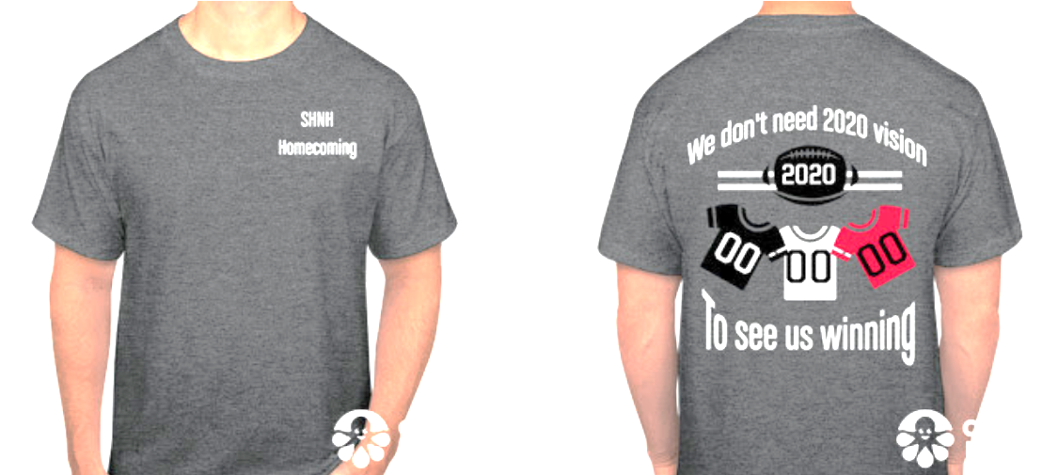
Name___________________________
T-Shirts are Heather Gray with white font. The back has white font and the jerseys are black, white, & red

Youth $11.00 XXL $13.00
Youth S _______ XXL ______
Youth M _______ XXXL $14.00
Youth L _______ XXXL ______
Youth XL _______ 4XL $15.00
Adult $11.00 4XL _______
Adult XS _______
Adult S _______
Adult M _______
Adult L _______
Adult XL _______
Total # of Shirts _______
Total $ _________
Please have order forms turned in by September 22nd
Money must be paid in full by September 28th
Make checks payable to Nodaway-Holt

